Poshmark Company
Student’s Name
Institution
Date
Poshmark Company
My research is related to the description of technology-enabled innovations at Poshmark Company. The company is a social commerce platform that enables users to purchase items. The organization has over 40 million users on its social commerce platform. It creates its retail brands through launching innovative features. Poshmark Company contains technology-enabled innovations that assist customers to make purchases of their goods. Firstly, the organization has developed a commenting and rating system that gets used in communicating (Jin, & Shin, 2020). The technological innovation helps in promoting robust network effects that attract more sellers and buyers. Communication can get developed through the technological platform that allows interaction s to get maintained. All the posts made by sellers can get received by buyers who make payment of what they need. Technological innovations that promote audience building would ensure the selling of merchandise gets enhanced.
Again, the buyers would get directed by liking and commenting on merchandise on the company's platform. Seller leverage category tags would make it easy for buyers to determine what they need to purchase. The technological innovation of liking and commenting provides platforms for Poshmark Company to understand consumers' reactions. Advertisement of good gets conducted at the website of the organization. Technological advancement assists in promoting increased consumer and sellers' relationships. The creation of websites makes consumers from all parts of the world gets reached. The success of using technological innovations has led to the achievement of much profit by Poshmark Company. The venture business has promoted productive engagement between buyers and sellers. Purchases of goods get made online within the company's website. E-commerce is essential for making the right payment for purchased goods.
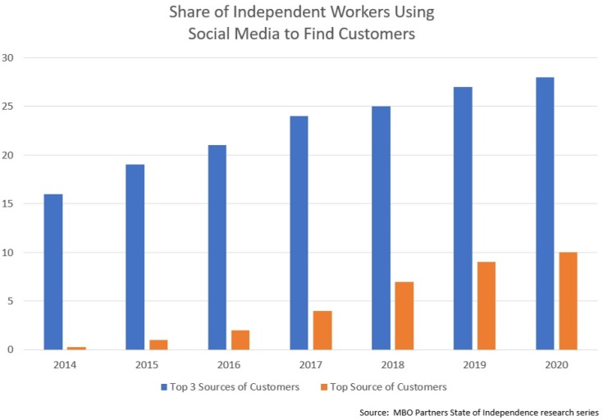

References
Jin, B. E., & Shin, D. C. (2020). Changing the game to compete: Innovations in the fashion retail industry from the disruptive business model. Business Horizons, 63(3), 301-311.

